**CHAPTER 4 – SYSTEM DESIGN DESCRIPTION**

**4.1. Introduction**

**4.1.1. Purpose**

System Design Description (SDD) provides a comprehensive architectural overview system. They are the technical, user interface (UI) and hardware interface design. It includes the architectural design and the detailed design. The architectural design describes the overall architecture of the system, and the architecture of each main component and subsystem. It will describe the patterns is being used, the role of each component and the role of the system in the working environment. The detailed design describes static and dynamic structure for each component and function.

The SDD describes design goals and considerations, provides a high-level overview of the system architecture, and describes the data design associated with the system, as well as the human-machine interface and operational scenarios. The high-level system design is further decomposed into low-level detailed design specifications for each of the system’s components, including hardware, internal communications, software, system integrity controls, and external interfaces.

SDD is to give the developer team a guidance of what the system’s architecture is, and how they implement.

**4.1.2. Design Overview**

This document consists of:

* Architecture overview
* Component diagram
* Detailed design
* Detailed description of components

**4.2. System Architectural Overview**

**4.2.1. System Architecture**

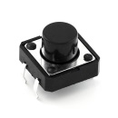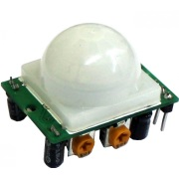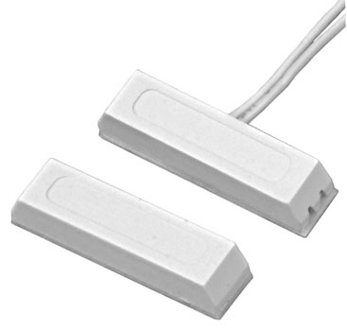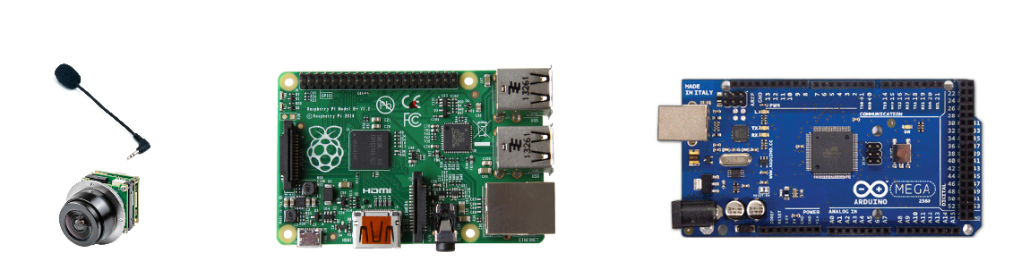

**SIP Server**

**Push Server**

***Note:***

|  |  |
| --- | --- |
|  | Wired Connection |
|  | Wireless Connection |

**4.2.2. System Architecture Explaination**

HSS’s system architecture has two main parts. They are **Central Circuit Board** (whose devices are being connected together by wired connection includes Raspberry Pi and Arduino – each in one block; microphone, speaker and camera in one block and sensor block) and **Application Solution** (which includes Android application and other services connected through Internet).

Via WLAN that was launched by your existing router in house, Android application will connected to

**4.2.3. HSS Client Application Architecture**

**4.2.3.1. Sequence Diagram**

**<Hưng>**

**4.2.3.2. Implementation**

**4.3. Detailed Design of HSS hardware**

**4.3.1. Hardware Components**

**4.3.1.1. Raspberry Pi Model B+ V1.2**

**4.3.1.1.1. Overview**

The Raspberry Pi is a series of credit card–sized single-board computers developed in England, United Kingdom by the Raspberry Pi Foundation with the intent to promote the teaching of basic computer science in schools and developing countries. The original Raspberry Pi and Raspberry Pi 2 are manufactured in several board configurations through licensed manufacturing agreements with Newark element14 (Premier Farnell), RS Components and Egoman. The hardware is the same across all manufacturers.

**4.3.1.1.2. Photos**

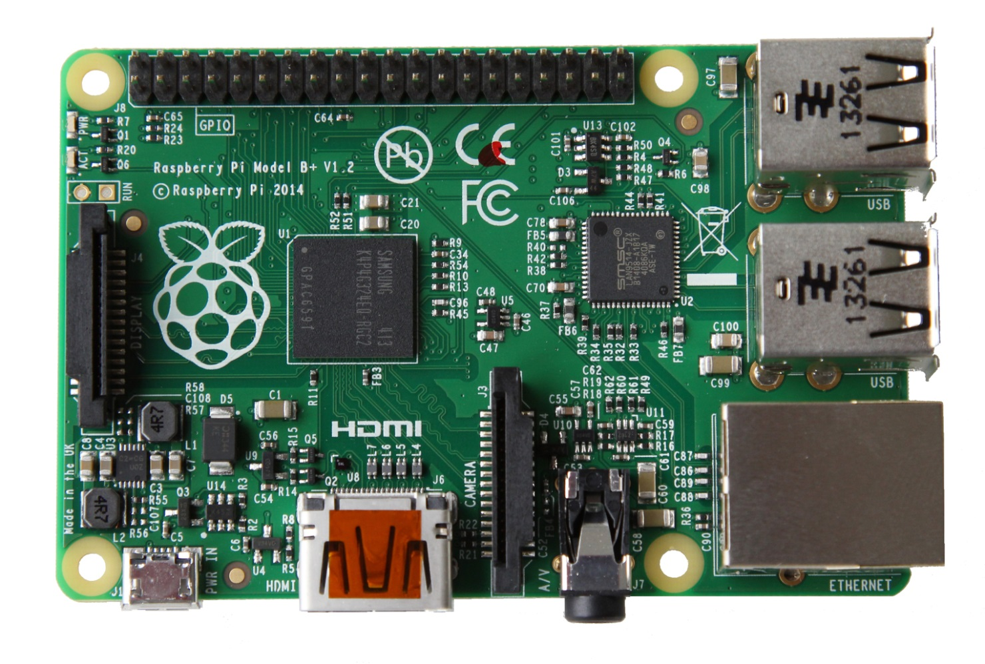

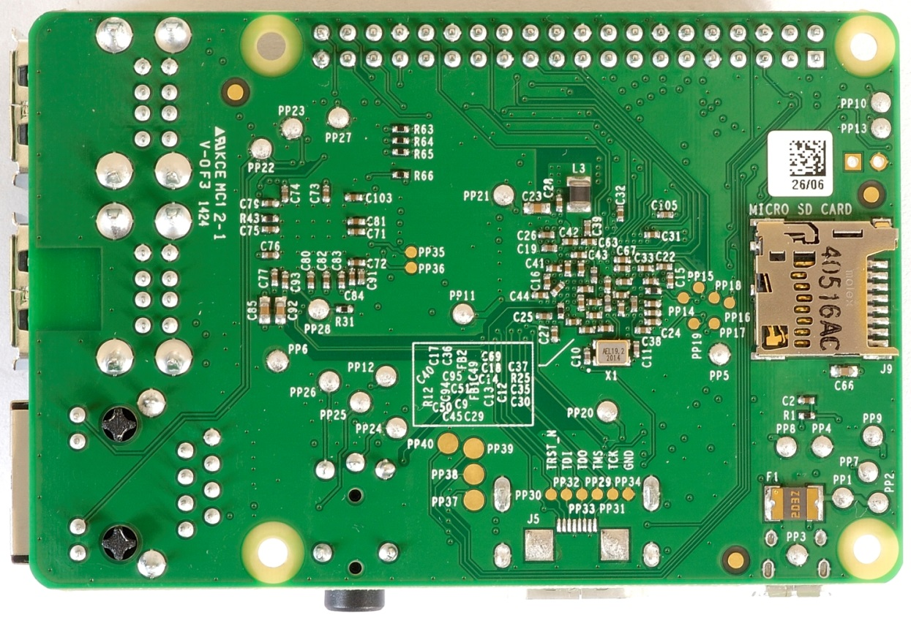

**4.3.1.1.3. Summary**

|  |  |
| --- | --- |
| *CHARACTERISTICS* | *VALUE* |
| SoC | Broadcom BCM2835 |
| CPU | 700 MHz single-core ARM1176JZF-S |
| CPU | BCM2837: 3D part of GPU @ 300 MHz, video part of GPU @ 400 MHz |
| Memory (SDRAM) | 512 MB (shared with GPU) |
| USB 2/0 Ports | 4 |
| Video Input | 15-pin MIPI camera interface connector |
| Video Output | HDMI (rev 1.3 & 1.4), composite video (3.5 mm TRRS) |
| Audio Input | As of revision 2 boards via I²S |
| Audio Output | Analog via 3.5 mm phone jack; digital via HDMI |
| On-board Storage | MicroSDHC Slot |
| On-board Network | 10/100 Mbit/s Ethernet (8P8C) or USB hub |
| Low-level peripherals | 17× GPIO plus the same specific functions, and HAT ID bus |
| Power | 600 mA (3.0 W) |

**4.3.1.1.4. Schematic**

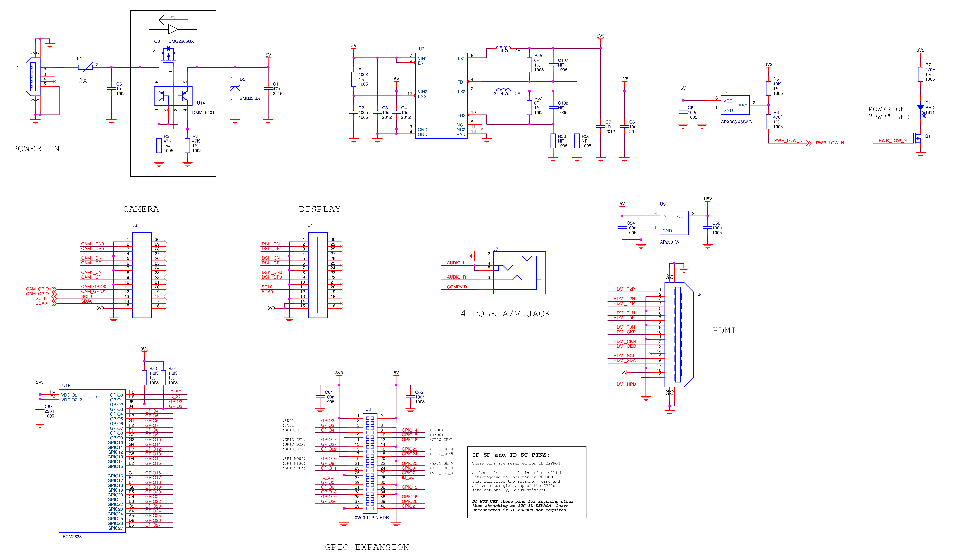

**4.3.1.2. Arduino Mega 2560**

**4.3.1.2.1. Overview**

Arduino MEGA 2560 designs for more complex project. It is a microcontroller board based on the ATmega2560. It has 54 digital input/output pins (of which 14 can be used as PWM outputs), 16 analog inputs, 4 UARTs (hardware serial ports), a 16 MHz crystal oscillator, a USB connection, a power jack, an ICSP header, and a reset button. It contains everything needed to support the microcontroller, simply connect it to a computer with a USB cable or power it with an AC-to-DC adapter or battery to get started. The Mega is compatible with most shields designed for the Arduino Duemilanove or Diecimila.

**4.3.1.2.2. Photos**

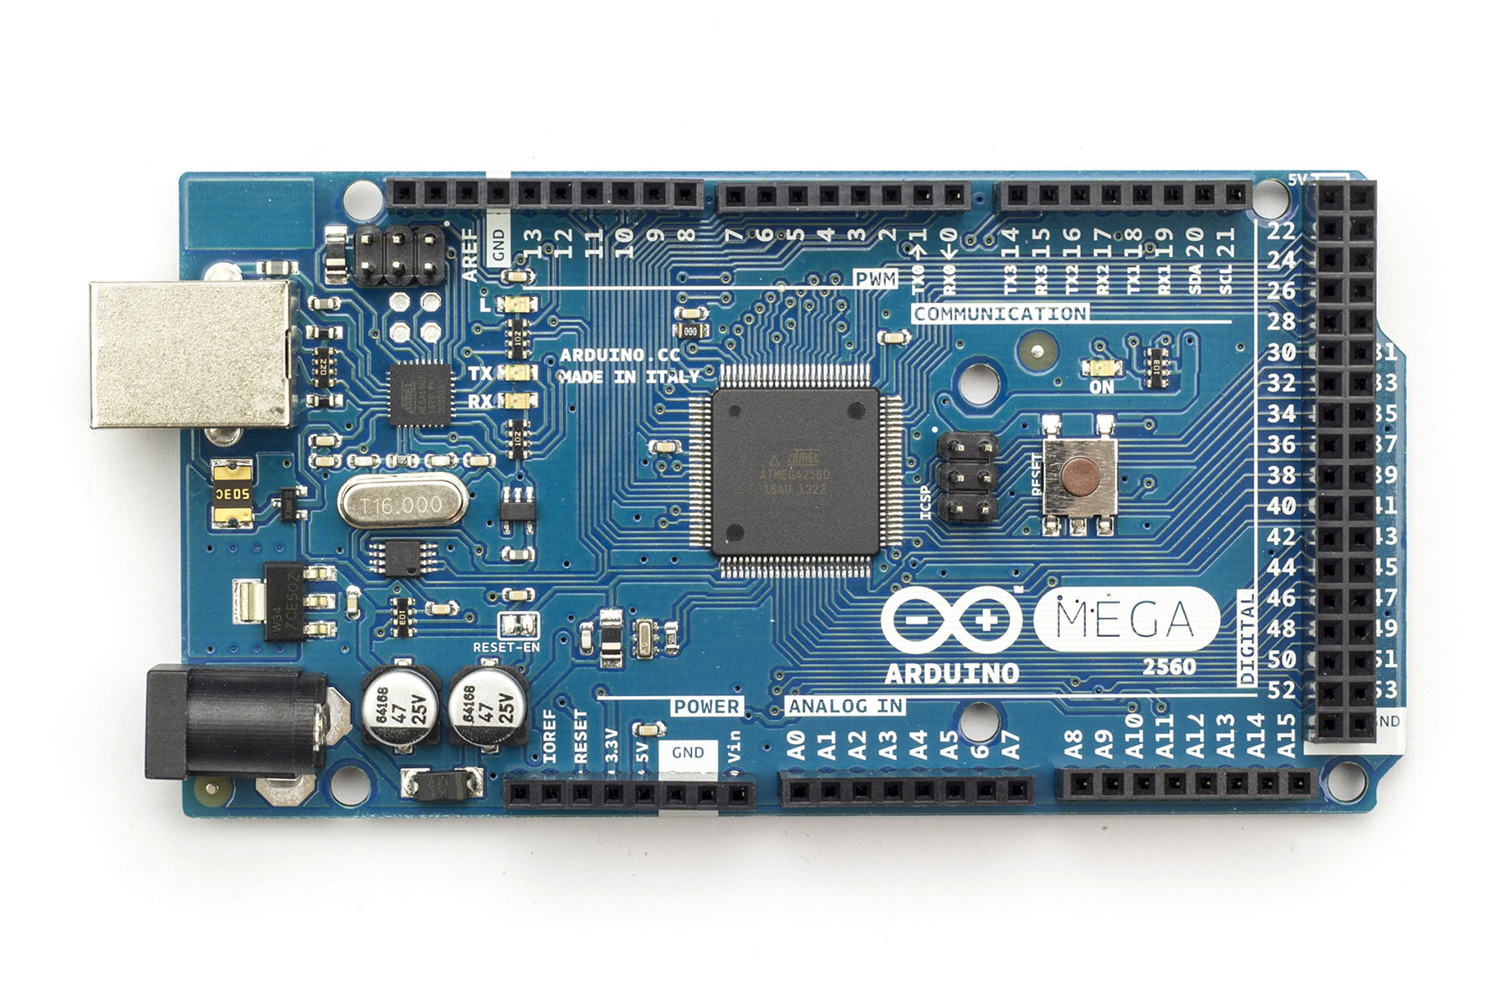

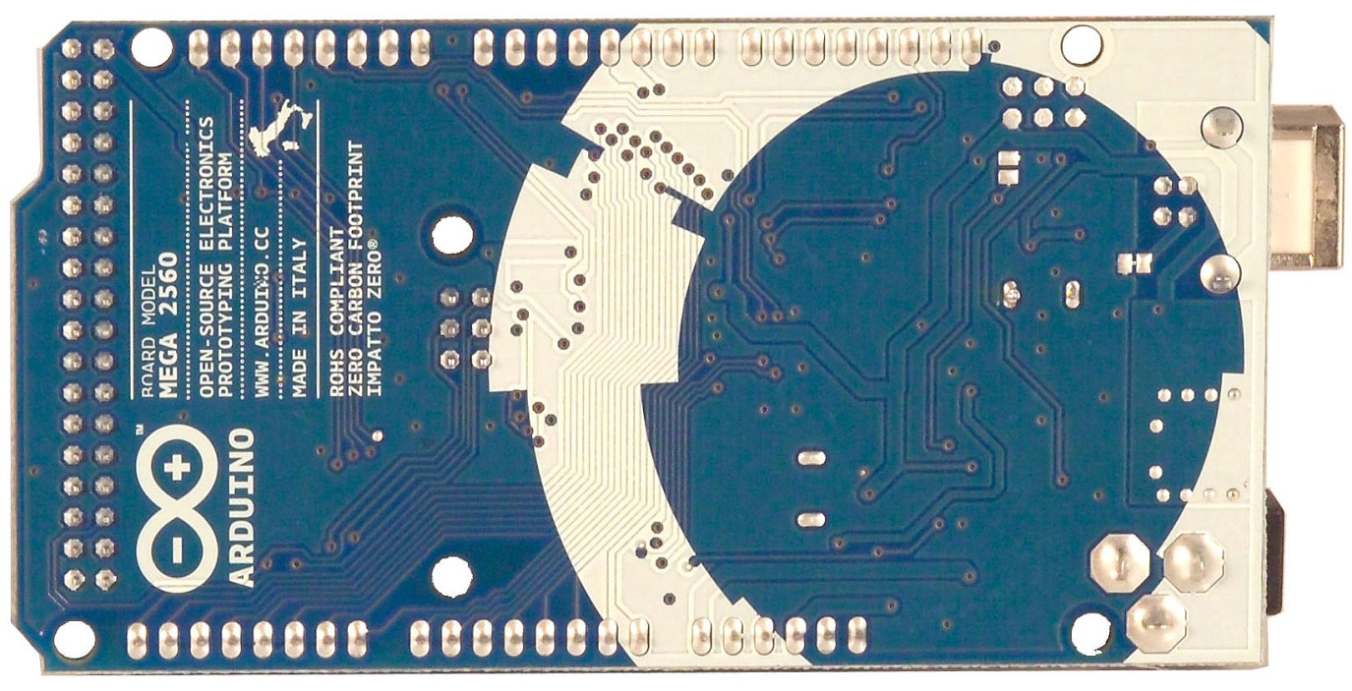

**4.3.1.2.3. Summary**

|  |  |
| --- | --- |
| *CHARACTERISTICS* | *VALUE* |
| Microcontroller | ATmega2560 |
| Operating Voltage | 5 V |
| Input Voltage (recommended) | 7-12 V |
| Input Voltage (limits) | 6-20 V |
| Digital I/O Pins | 54 (of which 14 provide PWM output) |
| Analog Input Pins | 16 |
| DC Current per I/O Pin | 40 mA |
| DC Current for 3.3 V Pin | 50 mA |
| Flash Memory | 256 KB of which 8 KB used by bootloader |
| SRAM | 8 KB |
| EEPROM | 4 KB |
| Clock Speed | 16 MHz |

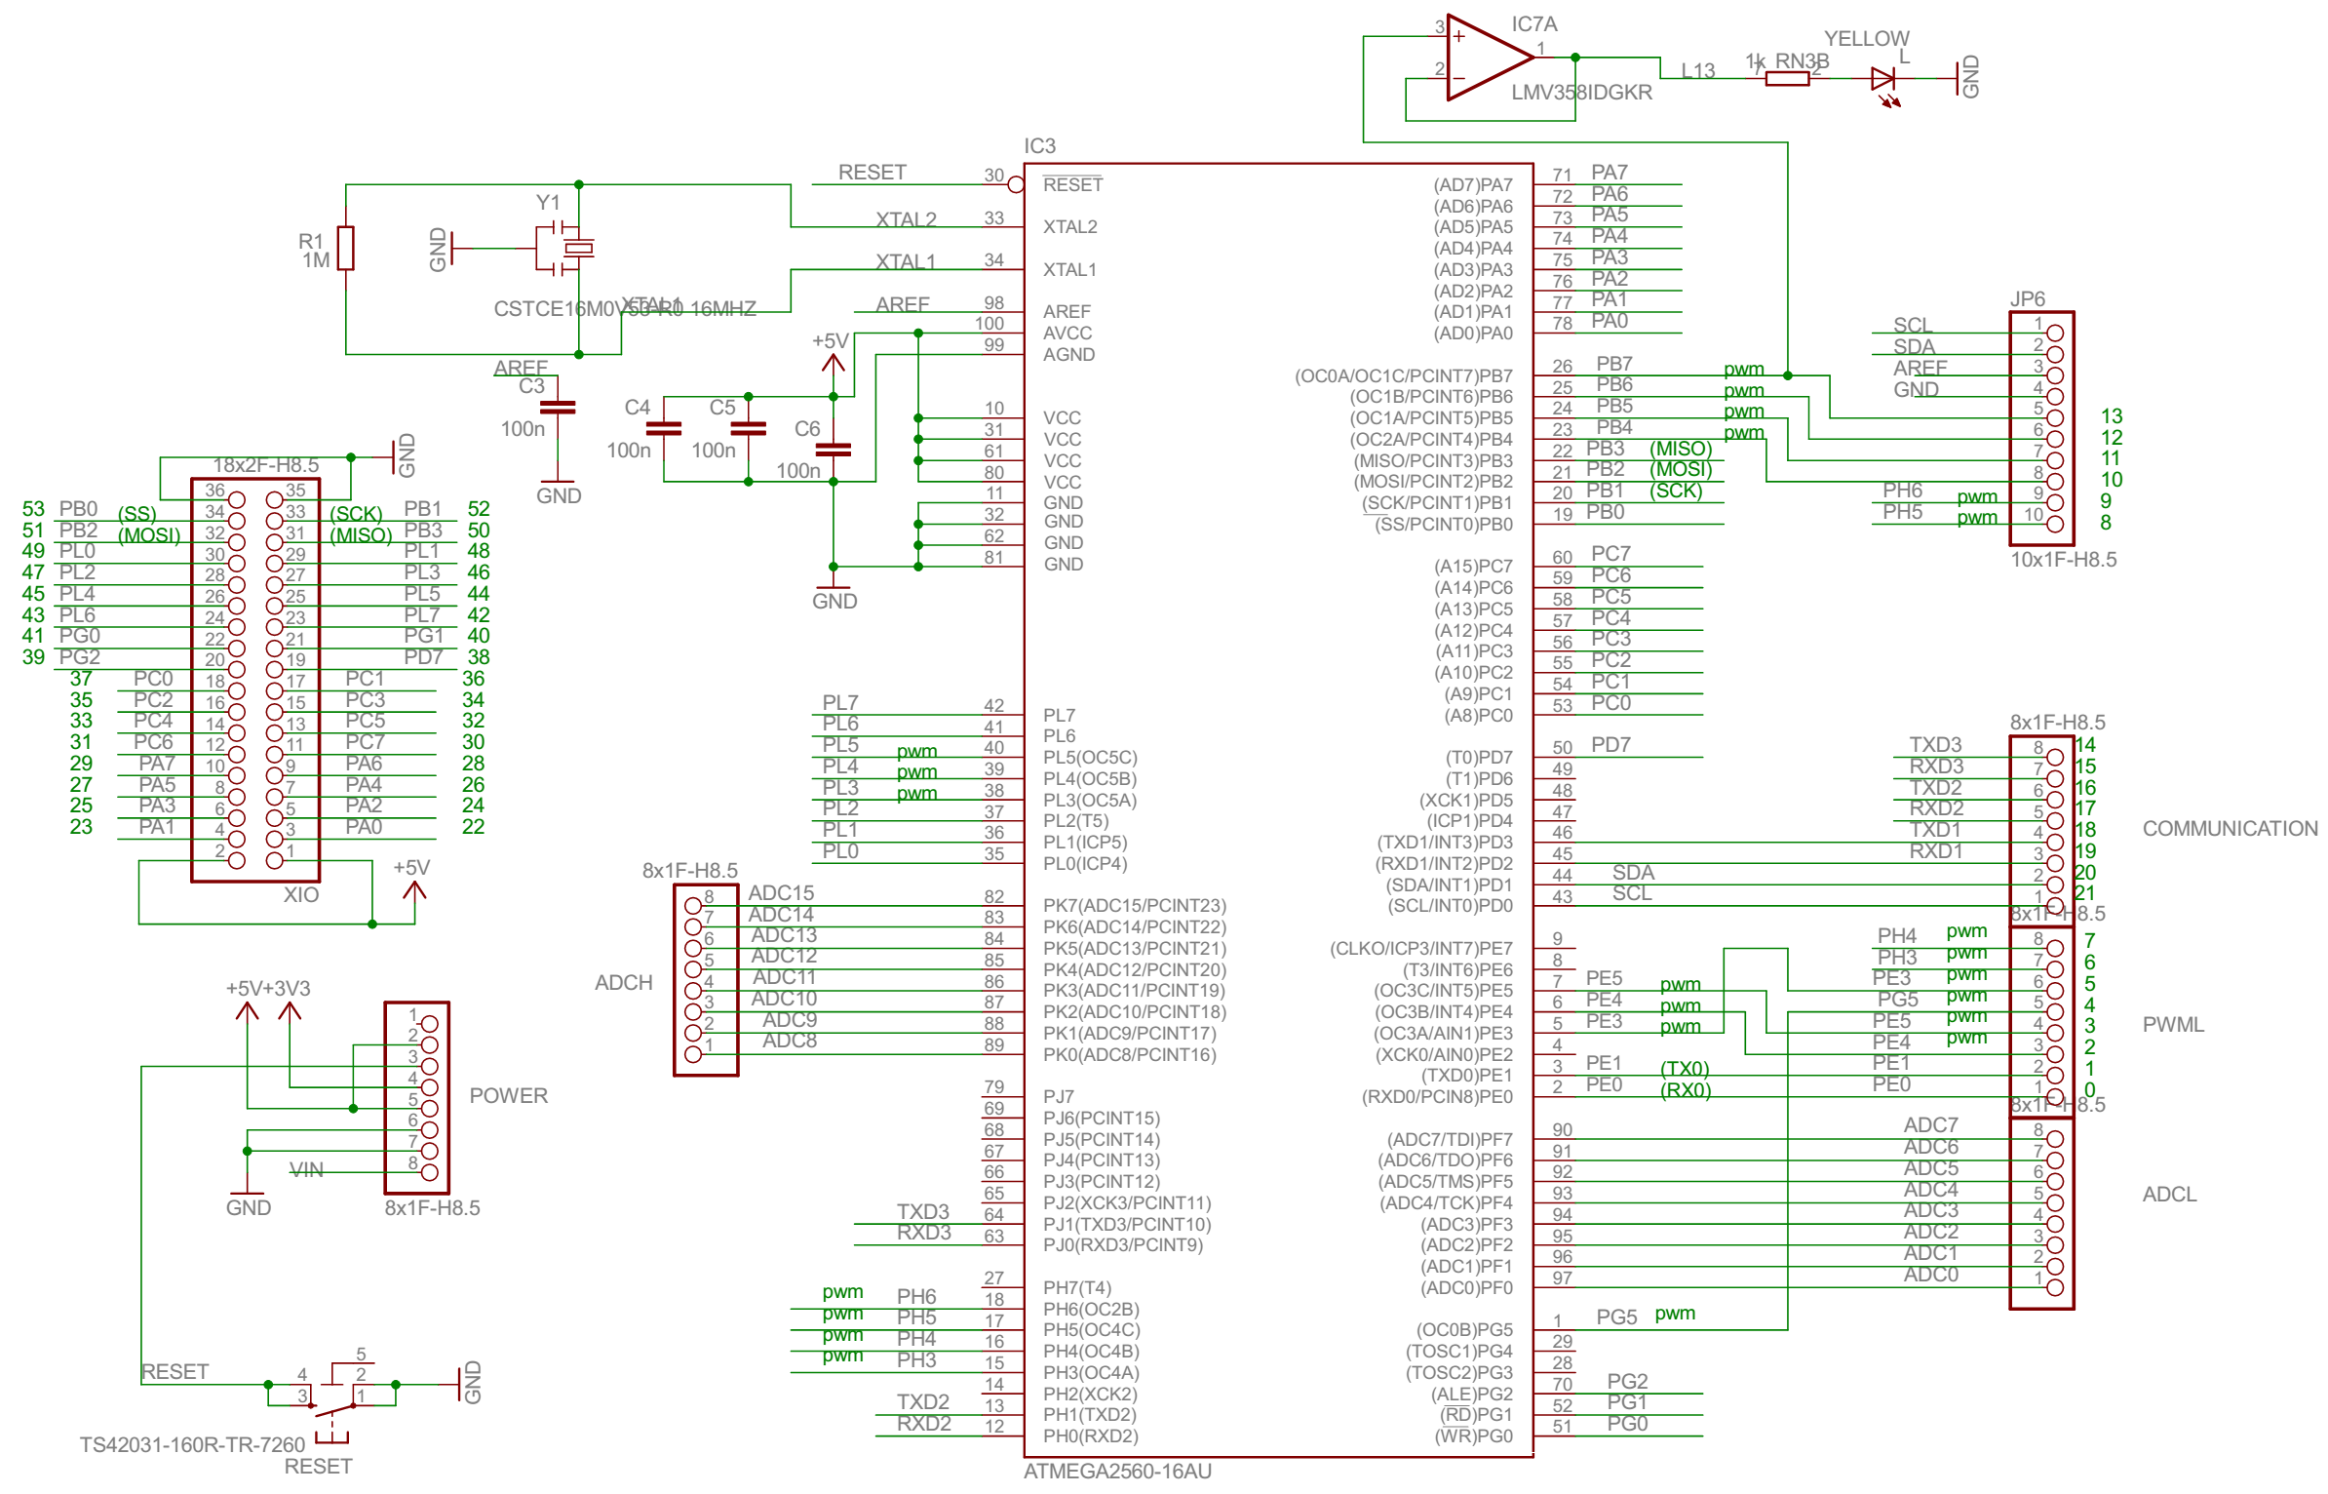 **4.3.1.2.4. Schematic**

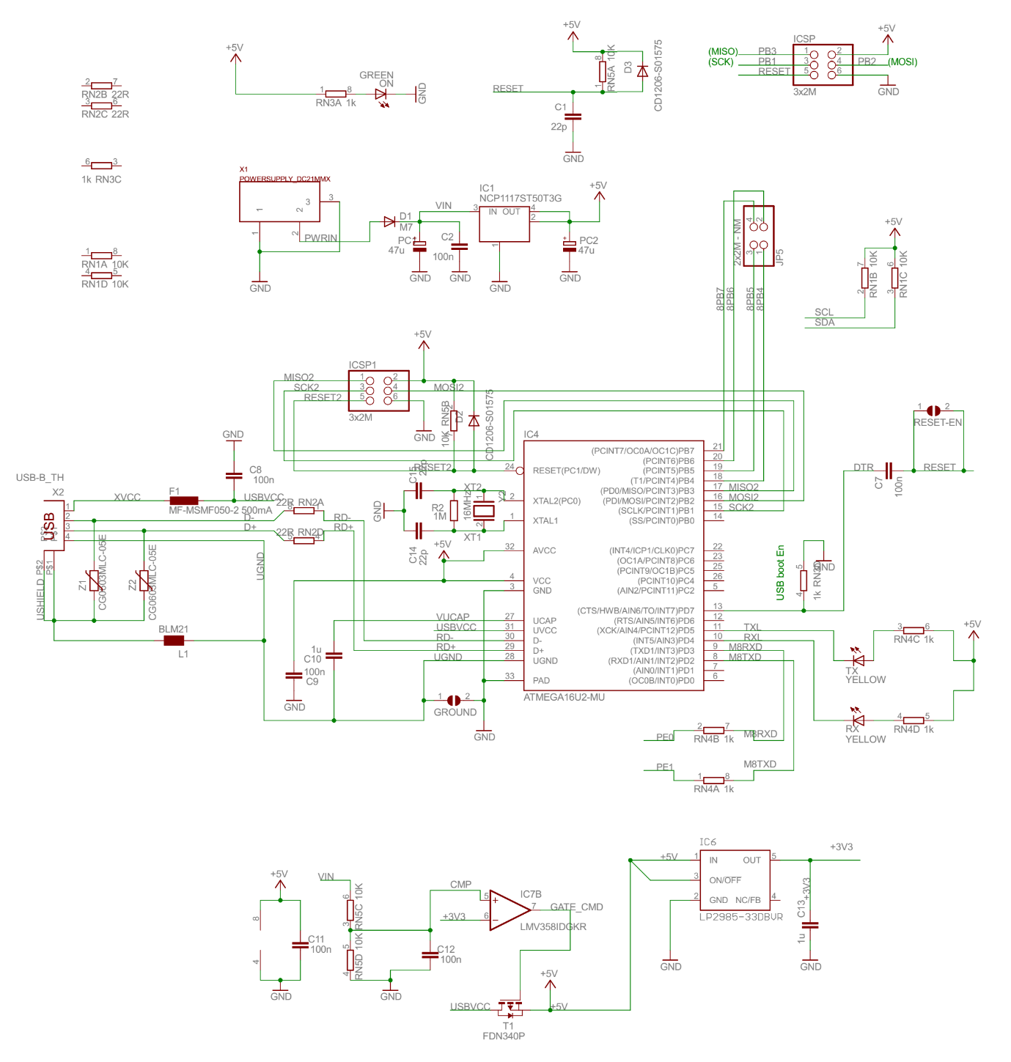 **4.3.1.3. USB WiFi Adapter TL-725N V2**

**4.3.1.3.1. Overview**

Default Raspberry Pi can only access your home network using a network cable. But let’s face it, your Raspberry Pi project is not always going to be deployed close to a network outlet – so what should we do? The best solution is to buy a cheap USB Wi-Fi adapter and use one of the USB ports to access our wireless home network. TL-WN725N V2 USB Adapter is the best choice for this issue. It is known as a hard one to get working on Raspberry Pi (even Raspberry Pi B+ 2014 v1.2)

**4.3.1.3.2. Photos**

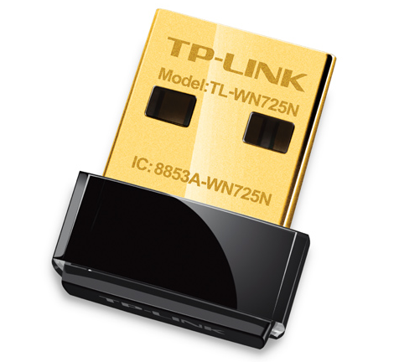

**4.3.1.3.3. Summary**

|  |  |
| --- | --- |
| *CHARACTERISTICS* | *VALUE* |
| Interface | USB 2.0 |
| Dimensions | 18.6x15x7.1mm |
| Antenna | Internal antenna |
| LED | Status |
| Weight | 2.1 grams |

**4.3.1.4. PIR Sensor**

**4.3.1.4.1. Overview**

A passive infrared sensor (PIR sensor) is an electronic sensor that measures infrared (IR) light radiating from objects in its field of view. They are most often used in PIR-based motion detectors.

**4.3.1.4.2. Operating Principle**

All objects with a temperature above absolute zero emit heat energy in the form of radiation. Usually this radiation is invisible to the human eye because it radiates at infrared wavelengths, but it can be detected by electronic devices designed for such a purpose.

Everything emits some low level radiation, and the hotter something is, the more radiation is emitted. The sensor in a motion detector is actually split in two halves. The reason for that is that we are looking to detect motion (change) not average IR levels. The two halves are wired up so that they cancel each other out. If one half sees more or less IR radiation than the other, the output will swing high or low.

**4.3.1.4.3. Photos**

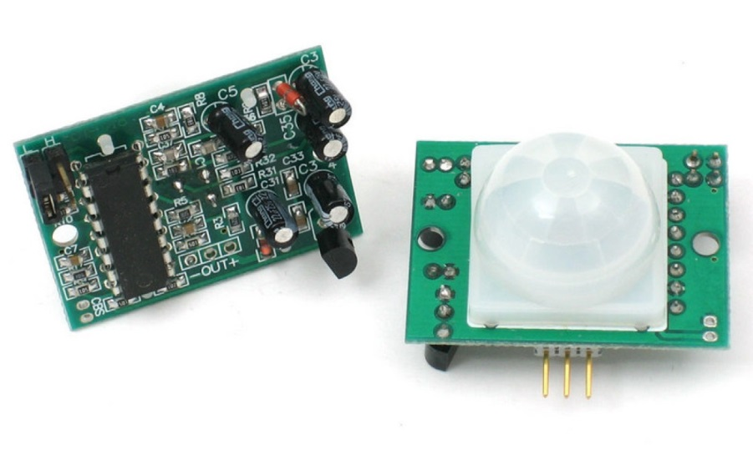

**4.3.1.4.4. Summary**

|  |  |
| --- | --- |
| *CHARACTERISTICS* | *VALUE* |
| SoC | BISS0001 PIR Chip |
| Output | Digital pulse high (3V) when triggered (motion detected) digital low when idle (no motion detected). Pulse lengths are determined by resistors and capacitors on the PCB and differ from sensor to sensor |
| Sensitive Range | up to 20 feet (6 meters) 110° x 70° detection range |
| Power Supply | 3V-9V input voltage, but 5V is ideal. |

**4.3.1.5. Magnetic Door Switch**

**4.3.1.5.1. Overview**

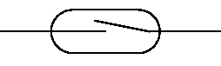 Magnetic Door Switch is based on reed switch. The reed switch is an electrical switch operated by an applied magnetic field. It was invented at Bell Telephone Laboratories in 1936 by W. B. Ellwood. It consists of a pair of contacts on ferrous metal reeds in a hermetically sealed glass envelope. The contacts may be normally open, closing when a magnetic field is present, or normally closed and opening when a magnetic field is applied. The switch may be actuated by a coil, making a reed relay, or by bringing a magnet near to the switch. Once the magnet is pulled away from the switch, the reed switch will go back to its original position.

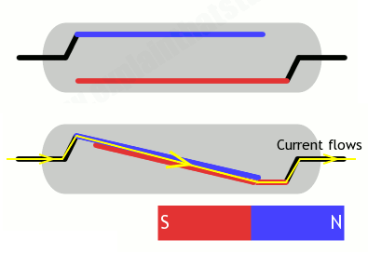 **4.3.1.5.2. Operating Principle**

You can also get reed switches that work the opposite way. The two contacts are normally snapped together. When you bring a magnet up to the switch, the lower contact is attracted to the magnet, the upper one is repelled, so the contacts split apart, opening the switch and breaking the circuit. Reed switches like this are called normally closed (NC) (normally switched on), and they switch off when you bring a magnet up to them.

**4.3.1.5.3. Photos**

